
COLLEGE OF COMPUTER STUDIES

CCS007L (COMPUTER PROGRAMMING 2)

EXERCISE
2

ARRAYS

Jed L. Hizon
Student Name / Group Name:
Name Role

Members (if Group):

AN11 – 2nd Term
Section:

Mr. Mark Cezar
Professor:
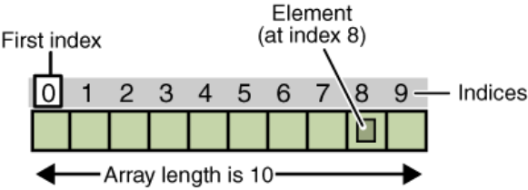

I. PROGRAM OUTCOME/S (PO) ADDRESSED BY THE LABORATORY EXERCISE

• Analyze a complex problem and identify and define the computing requirements appropriate to its solution. [PO: B]
• Design, implement and evaluate computer-based systems or applications to meet desired needs and requirements. [PO: C]

II. COURSE LEARNING OUTCOME/S (CLO) ADDRESSED BY THE LABORATORY EXERCISE

• Select and apply appropriate program constructs in developing computer programs. [CLO: 2]
• Develop, test and debug computer programs based on a given specification using the fundamental programming components. [CLO: 3]

III. INTENDED LEARNING OUTCOME/S (ILO) OF THE LABORATORY EXERCISE

At the end of this exercise, students must be able to:
• Emphasize the importance of arrays in creating C++ programs.
• Implement arrays in C++ programs in solving computing problems.

IV. BACKGROUND INFORMATION

An array is a container object that holds a fixed number of values of a single type. The length of an array is established when the array is created. After creation, its length is fixed.

An array consists of a name and the number of elements of the array. You can refer to a specific array element by the array name and the element number, which is known as the index number. Array index element number always starts with 0(zero).

Each item in an array is called an element, and each element is accessed by its numerical index. The 9th element, for example, would therefore be accessed at index 8.

Advantages of using Arrays

CCS007L-Computer Programming 2 Page 2 of 8

1. You can refer to a large number of elements by just specifying the index number and the array name.
2. Arrays make it easy to do calculations in a loop.

The various types of arrays in C++ are: • One-dimensional arrays
• Multi-dimensional arrays

A. One-Dimensional Arrays

One-dimensional array is a list of variables of the same data type.

Declaring Arrays

A typical declaration for an array in C++ is:

data_type array_name[no. of elements];

Initializing Arrays

In both cases, local and global, when we declare an array, we have the possibility to assign initial values to each one of its elements by enclosing the values in braces { }.

data_type array_name[n]={val[0],val[1],..,val[n-1]};

Where n is the number of elements For example:
int num[5] = { 16, 2, 77, 40, 120 }; char word[3]={‘J’,’A’,’Y’};

Accessing the Values of an Array

The format is as simple as:
array_name[index] or variable_object_identifier=array_name[index];
Examples:
y = Number[0]; x = Pressure[8]; letter = Word[1];

Assigning Values to an Array

CCS007L-Computer Programming 2 Page 3 of 8

The format is as simple as: array_name[index]=element value;
Examples: Number[0]=-5; Traffic[1]=“Green”; Word[1]=‘J’;

B. Multidimensional Arrays

In additions to one-dimensional arrays, you can create two-dimensional arrays. To declare two-dimensional arrays, you need to specify multiple square brackets after the array name. Multidimensional arrays can be described as "arrays of arrays".

A two dimensional array has two subscripts/indexes. The first subscript refers to the row, and the second, to the column. Its declaration has the following form:

data_type array_name[row][column];

For examples: int x[3][4];
float matrix[20][25];

The first line declares x as an integer array with 3 rows and 4 columns and the second line declares a matrix as a floating-point array with 20 rows and 25 columns.

Accessing Elements in Two-Dimensional Array

Accessing an element in a multidimensional array has the following form:

array_name[row_index][column_index];

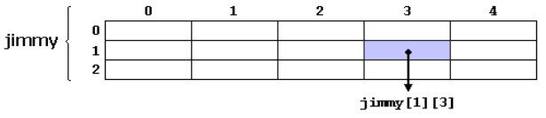
For example, the way to reference the second element vertically and fourth horizontally in an expression would be:

V. LABORATORY ACTIVITY

ACTIVITY 2.1: Even and Its Position

CCS007L-Computer Programming 2 Page 4 of 8

Write a program that identifies the position of all even numbers in an array of 10 elements.

Sample Output:
Enter 10 numbers: 4 6 7 9 11 13 15 16 20 23 Even numbers are located at indices: 0 1 7 8

Program: (save as [surname_2_1.cpp])
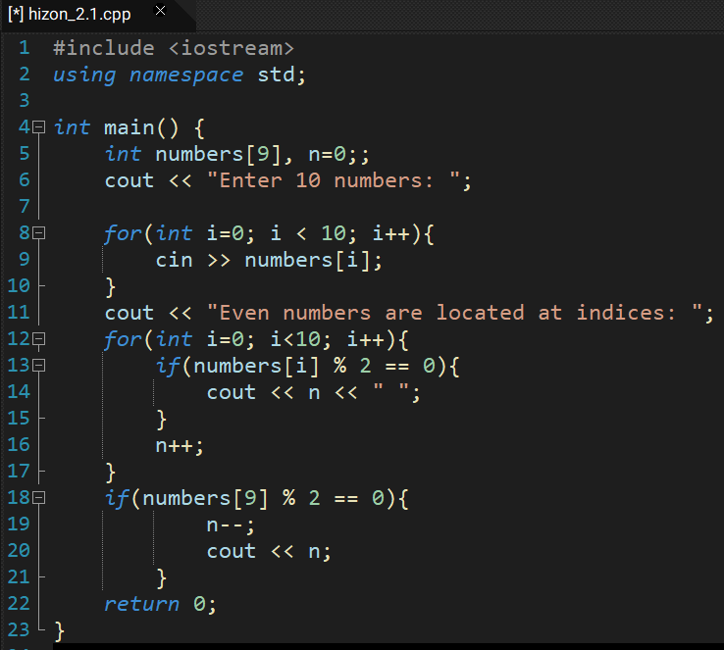

Output:(screenshot of the output)

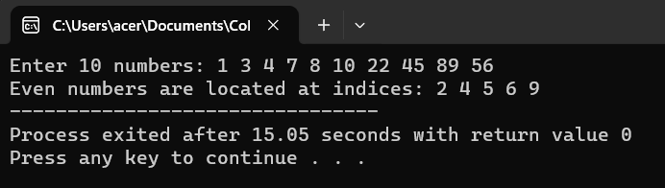

ACTIVITY 2.2: Sorting Values in an Array

Write a program that will ask the user to enter the size of the array n < 100. Once the array size is validated, it is required that the user will enter the elements of the array. Finally, display the sorted array elements using any sorting algorithm from smallest to greatest.

Sample Output:
Enter the size of the array: 4 Array element 1: 6
Array element 2: 4 Array element 3: 5 Array element 4: 2
The sorted array is: 2 4 5 6

Program: (save as [surname_2_2.cpp])

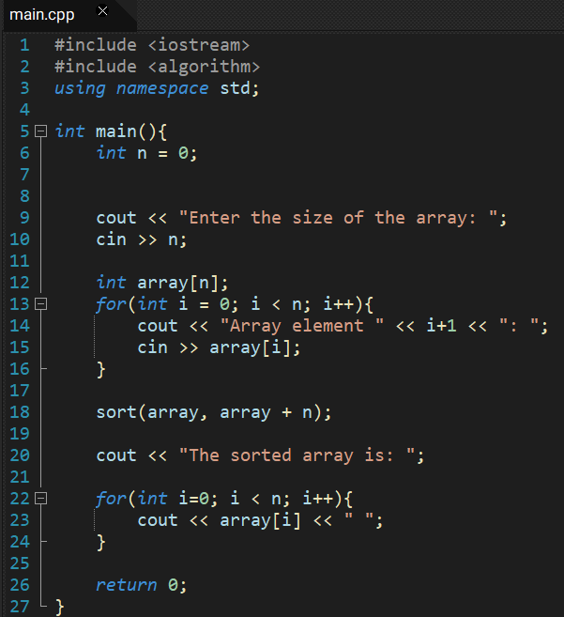

CCS007L-Computer Programming 2 Page 5
Output:(screenshot of the output)
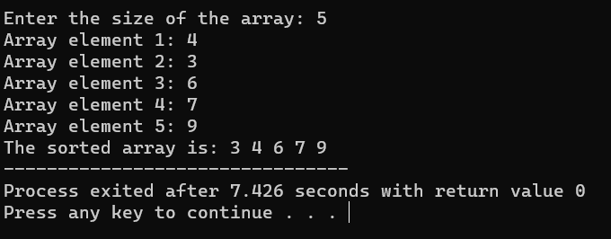

ACTIVITY 2.3: Finding Vowels and Whitespaces

Write a program that counts the number of vowels and whitespaces in a string. The user’s input should be all capital letters only.

Sample Output:
Enter a string: WELCOME TO ARRAYS Vowels:
A 2 E 2 I 0 O 2 U 0
Whitespaces – 2

4
Program: (save as [surname_2_3.cpp])

CCS007L-Computer Programming 2 Page 6 of 8
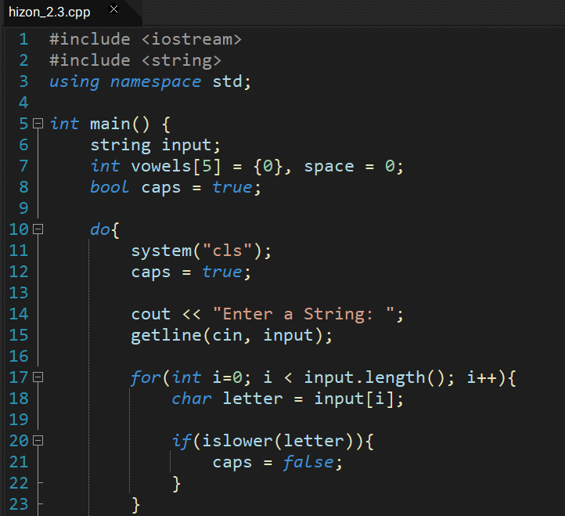

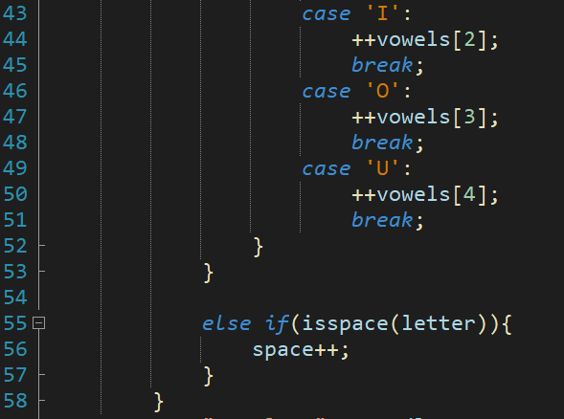
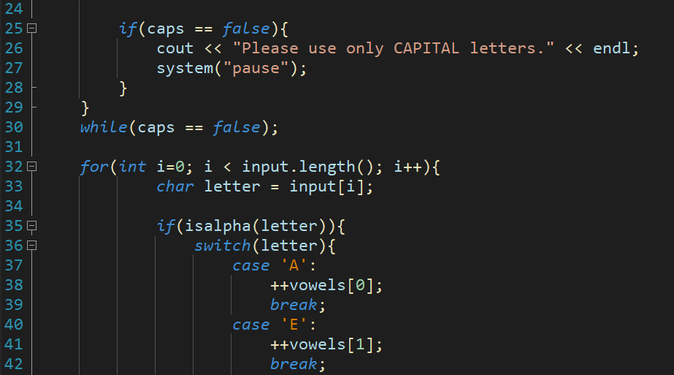
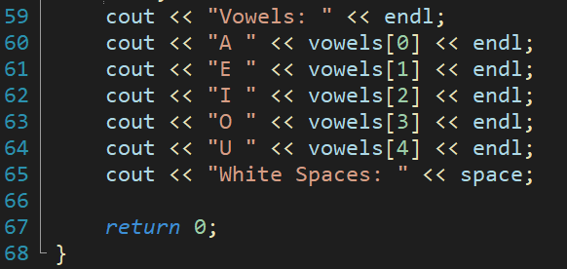

Output:(screenshot of the output)

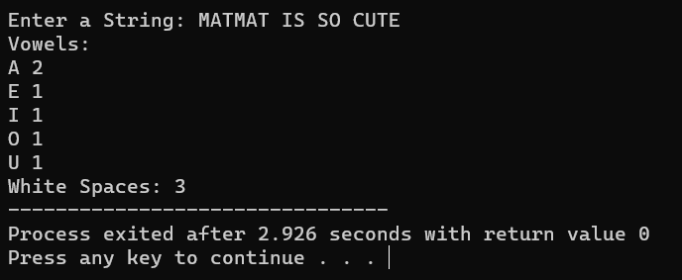

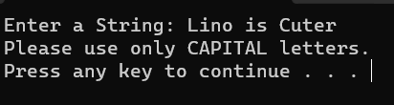

VI. QUESTION AND ANSWER

Directions: Briefly answer the questions below.

• Why is it necessary, being a programmer, to use arrays? What are the risks of not using arrays?

As a programmer, array is such an important part tool that we must utilize. Since this will help us allocate different variables much more efficiently. Not using arrays may still work, but the amount of work and how messy your code could be defeats your purpose as a programmer.

• When is two-dimensional or multidimensional array used in a program?

Programmers utilize two- or multi-dimensional arrays when they need to organize data, like matrices, tables, or photographs, into a grid-like layout. They are especially helpful for storing and manipulating structured data efficiently when it comes to expressing data with both row and column formats. Applications for multidimensional arrays can be found in many fields, such as image processing, game development, and mathematics.

VII. REFERENCES
• Abraham (2015). Coding for dummies. John Wiley and Sons: Hoboken, NJ • Zak, D (2015). An Introduction to Programming with C++. 8th Edition
• Cadenhead, R et. Al. (2016). C++ in 24 Hours, Sams Teach Yourself (6th Edition).Sams Publishing
• McGrath, M. (2017). C++ programming in easy steps (5th ed.). Warwickshire, United Kingdom: Easy Steps Limited
• Tale, T. (2016). C++: The Ultimate Beginners Guide to C++ Programing. CreateSpace Independent Publishing Platform
• http://cs.uno.edu/~jaime/Courses/2025/devCpp2025Instructions.html

CCS007L-Computer Programming 2 Page 8 of 8

